Student’s name | …………………………………………………….…… | Grade | 5
Subject | Computer | Week No. | 9
Lesson Title | Smart Art, Hyperlinks in PPT | Unit
Worksheet No. ( 9 ) (Answer)

Question A:
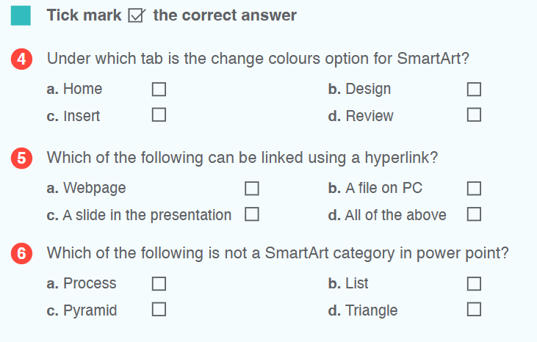
✔️
✔️
✔️
Good Luck

